**COPYRIGHT TRANSFER AGREEMENT FORM**

This letter is signed by me personally:

Name : 1) Fridiani Asiyah Rachmawati

Institution* : Universitas Negeri Yogyakarta

Email* : fridianiasiyah.2023@student.uny.ac.id/ phone +6282240155173

Place & date of birth* : Subang, 10 April 1999

Address* : Kp. Cinangsi RT 03 RW 01, Cibogo, Subang.

Title of Article : Effectiveness of E-Worksheet Renewable Energy on STEM-Project

Based Learning to Improve High School Students’ Critical thinking Skills and Collaboration Skills.

Article acceptance : date 28 month April year 2025

I declare that the submitted article is an original text, which was written by my self, and it is not the result of adaptation nor translated from other articles, and it has not yet been publshed in any media. I will be responsible for any potential damage to certain parties who feel personally harmed or legal claim of lawsuit due to the publication of this article.

I also submit the rights of ownership of submitted draft and article to the Editor Jurnal Pendidikan Fisika, and the Editor has right to reproduce and publishing either partial or entire contents of draft and article.

Thus, this statement has been drawn up to be used properly.

Yogyakarta, 29 April 2025

Author,

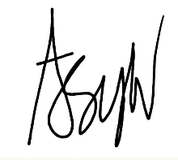

(Fridiani Asiyah Rachmawati)

*\* Write the name of Corresponding author*