**COPYRIGHT TRANSFER AGREEMENT FORM**

This letter is signed by me personally:

Name : 1) Siti Hajar

2) .........................................................................................................

3) .........................................................................................................

4) .........................................................................................................

Institution* : Cenderawasih University

Email* : siti_hajarfisica60@yahoo.com/ phone 082112104617

Place & date of birth* : Kombo, 25 June 1991

Address* : BTN Joko Indah Blok I.67 Dobonsolo District, Sentani District,

Jayapura District

Title of Article : Perceptions of the Use of EveryCircuit-Based Virtual Laboratory on

Dynamic Electricity Material

Article acceptance : date 12 month August year 2024

I declare that the submitted article is an original text, which was written by my self, and it is not the result of adaptation nor translated from other articles, and it has not yet been publshed in any media. I will be responsible for any potential damage to certain parties who feel personally harmed or legal claim of lawsuit due to the publication of this article.

I also submit the rights of ownership of submitted draft and article to the Editor Jurnal Pendidikan Fisika, and the Editor has right to reproduce and publishing either partial or entire contents of draft and article.

Thus, this statement has been drawn up to be used properly.

Jayapura, 12 August 2024

Author,

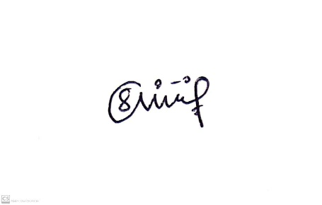

(Siti Hajar)

*\* Write the name of Corresponding author*