Author Statement Form:

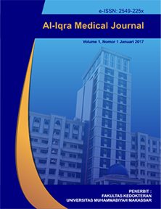

Manuscript Originality and Copyright Transfer Agreement

Al-Iqra Medical Journal : Jurnal Berkala Ilmiah Kedokteran

ISSN [2549-225X](http://u.lipi.go.id/1482292428) (online)

<https://journal.unismuh.ac.id/index.php/aimj/index>

Name of Principal/Corresponding Author*

dr. Kanti Ratnaningrum, M.Sc

Address of Principal/Corresponding Author*

Jl. Kedungmundu No.18, Kedungmungu, Kec. Tembalang, Kota Semarang, Jawa Tengah

Telephone*

085727878161

E-mail*

[kantiratna@unimus.ac.id](mailto:kantiratna@unimus.ac.id)

kantiratna@ymail.com

Fax*

-

All author(s) name*

Aulia Zulfiana Nur Faiza

Muh. Taufiqy Setyabudi

Kanti Ratnaningrum

Date of submitted*

Thursday, 2 Mei 2023

Manuscript title*

Analysis of Mother Characteristics and Pregnancy Conditions Associated with Events *Intra Uterine Fetal Death* (IUFD)

1. Declare that the article above is original. my own thoughts not translated, and has not been published elsewhere or currently not in the process of other journal publications. I am willing to be responsible if there are parties who feel disadvantaged privately and/or based on a lawsuit in the future by the publication of this article.
2. I also declare that any and all rights in and to the article including, without limitation, all copyrights are transferred to Al-Iqra Medical Journal : Jurnal Berkala Ilmiah Kedokteran. Therefore, the copyright transfer hands it the power and authority to edit, reproduce, distribute copies, and to publish the article partly or fully.

Semarang, 2 Mei 2023



dr. Kanti Ratnaningrum, M.Sc